Statistics for Engineers  
 Lab assessment – 1 Prashanth.S

19MID0020

1. **Sin function**

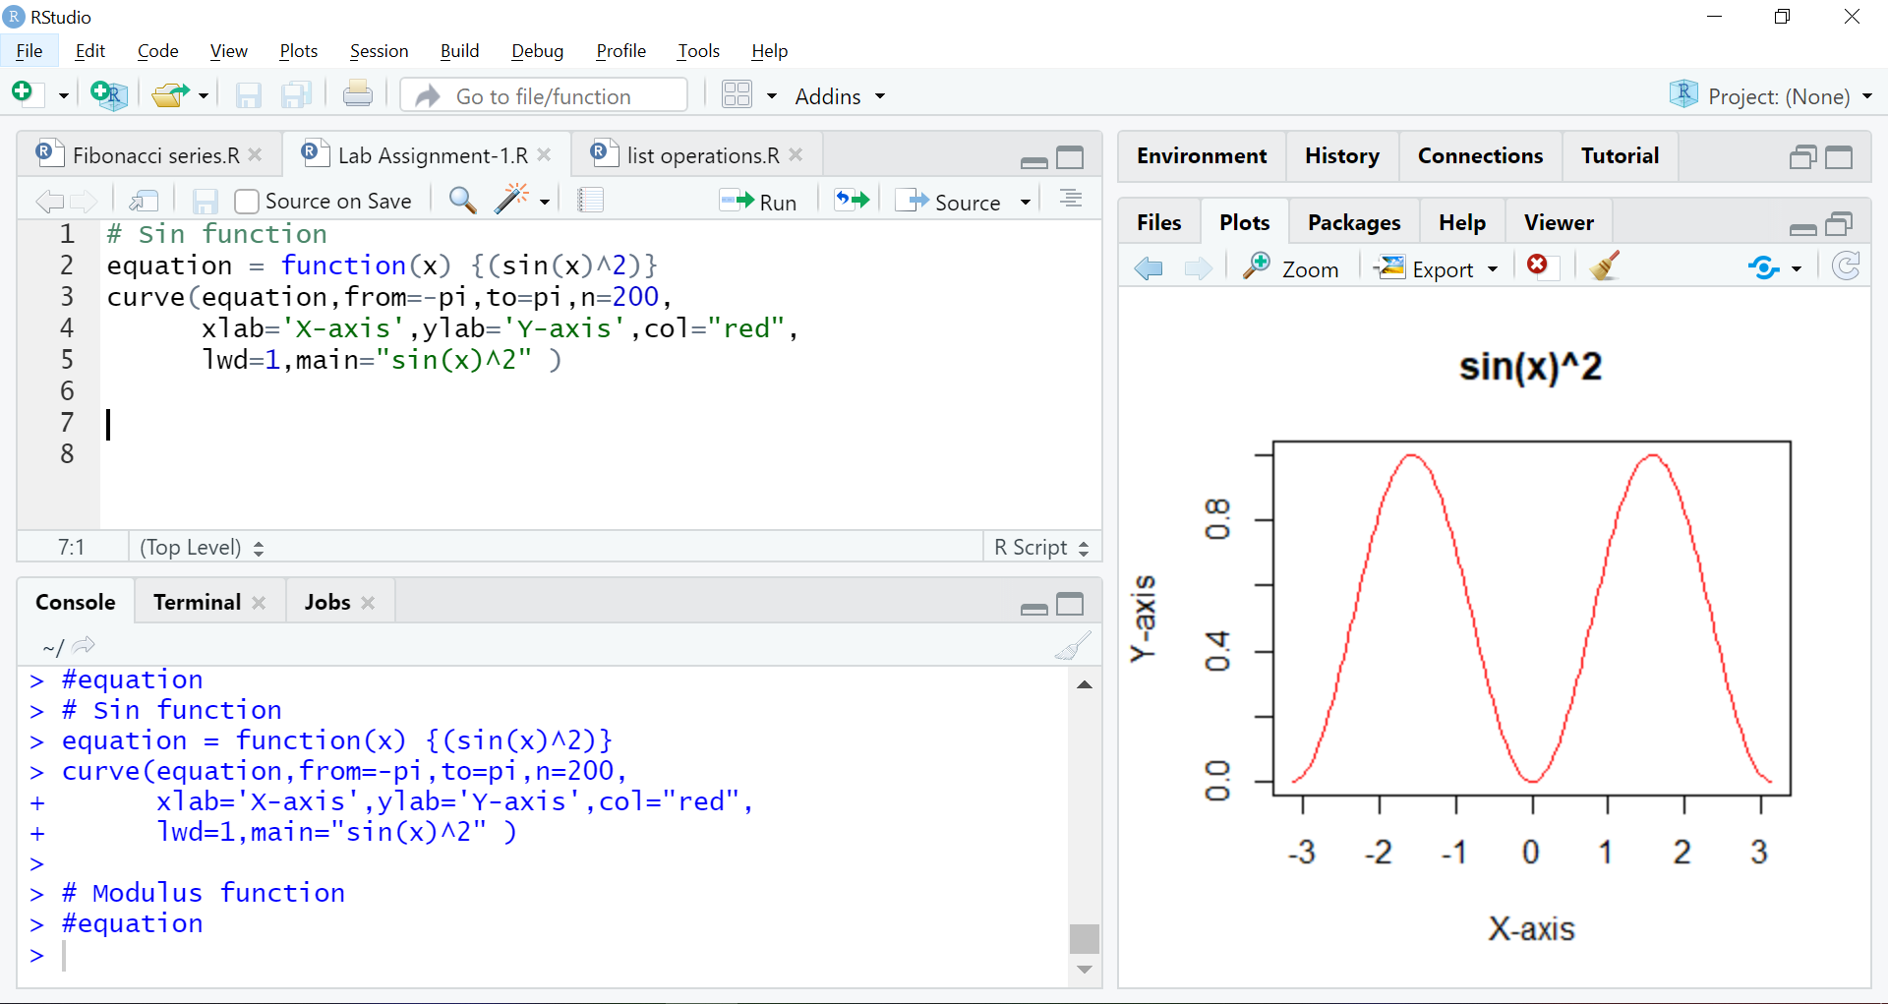

1. **Sin and cos function**

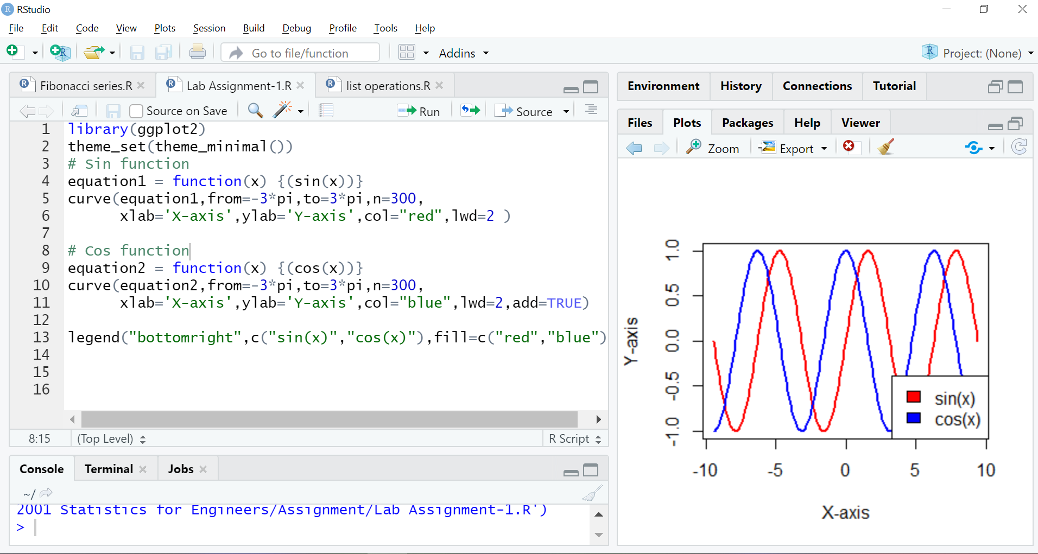

**3)Step-function**

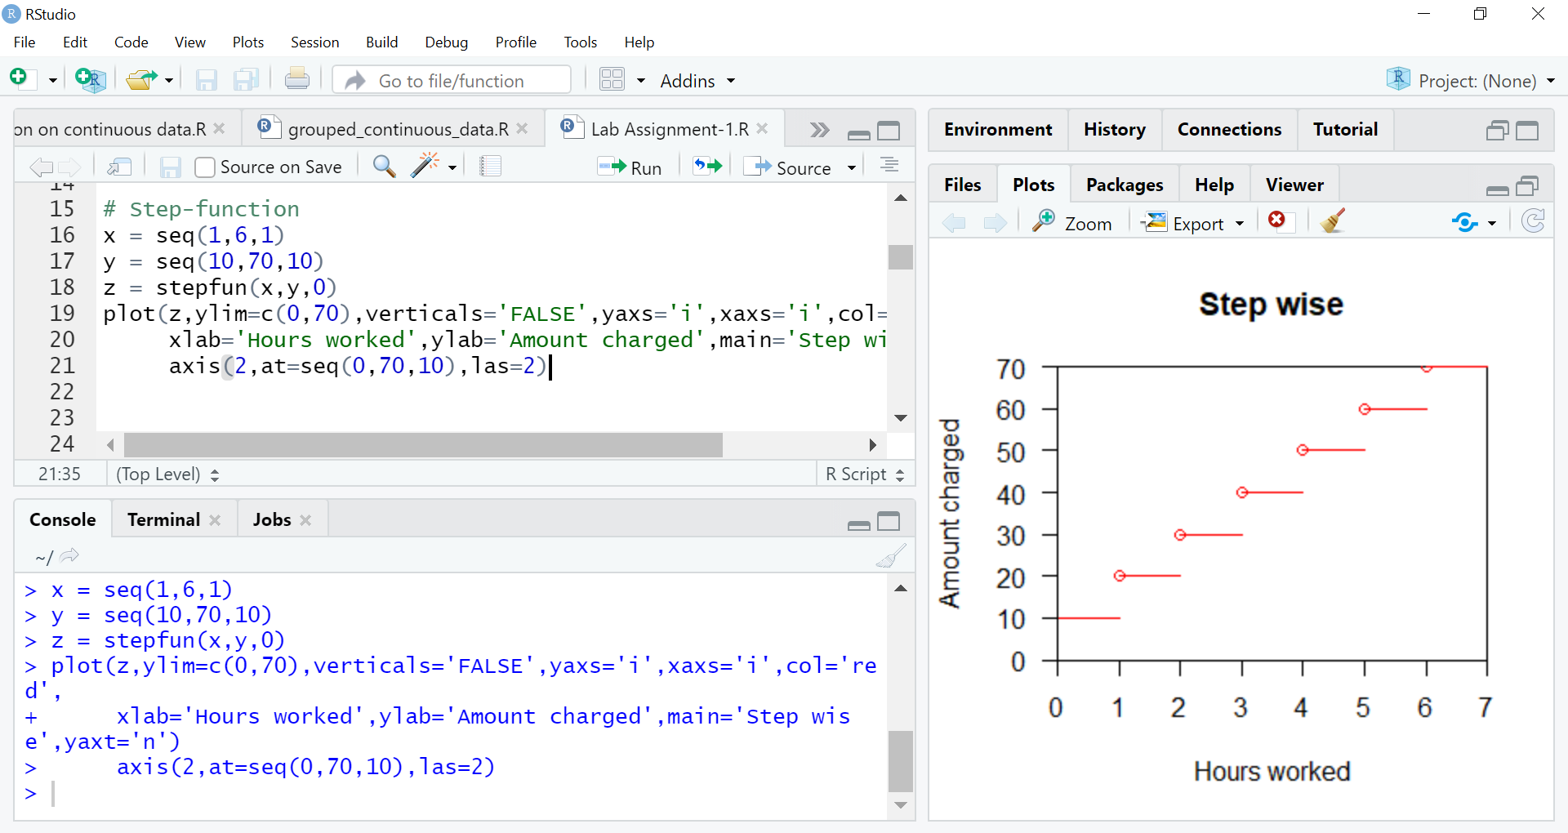

**3)Mod function**

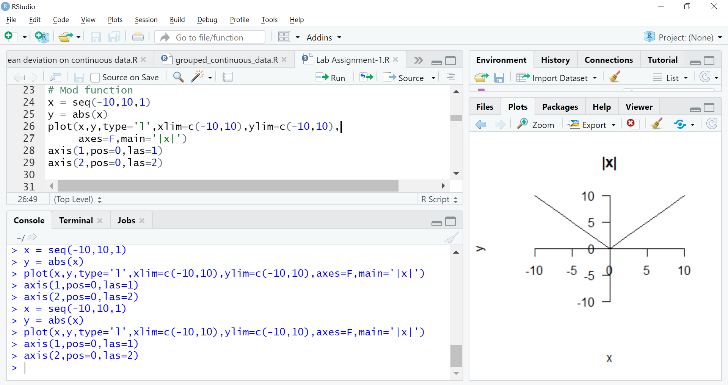

**5) Parabola**

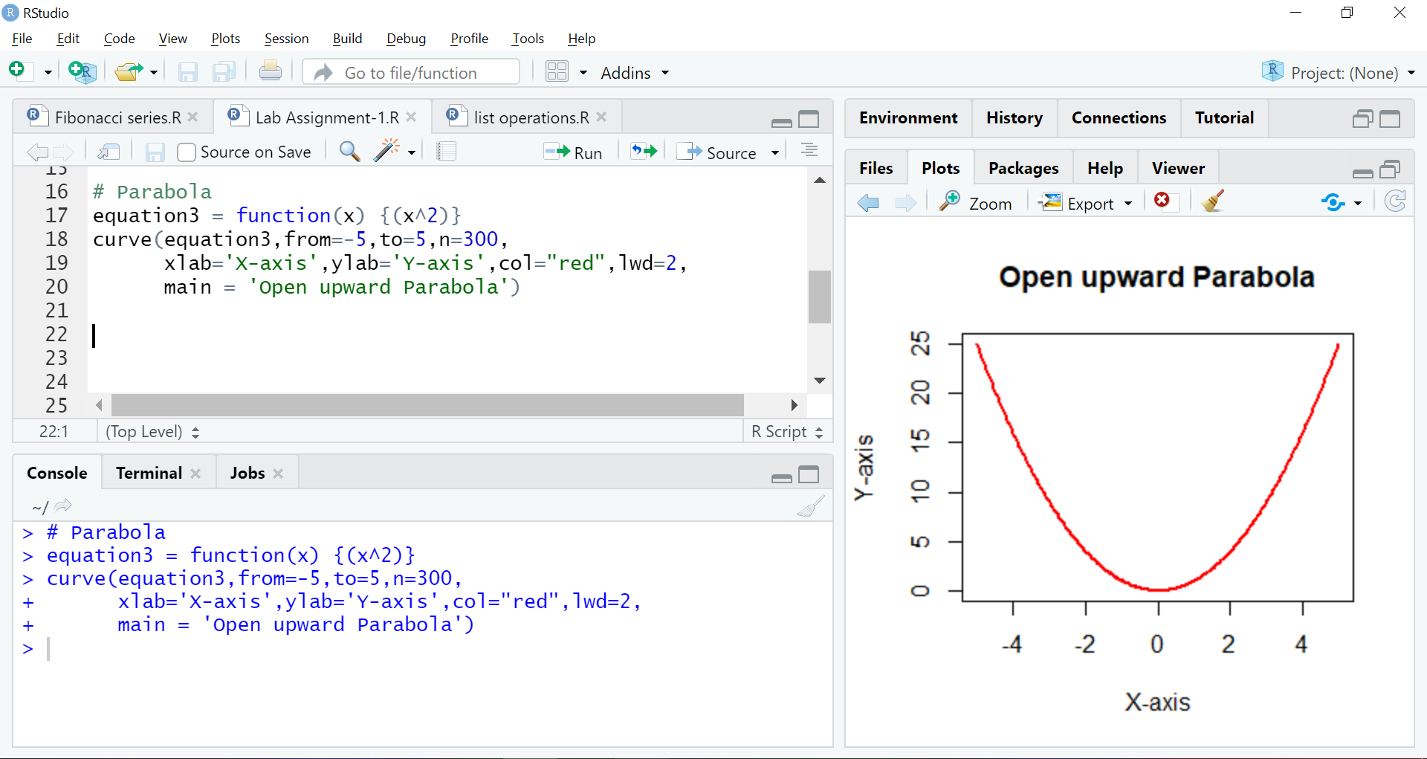

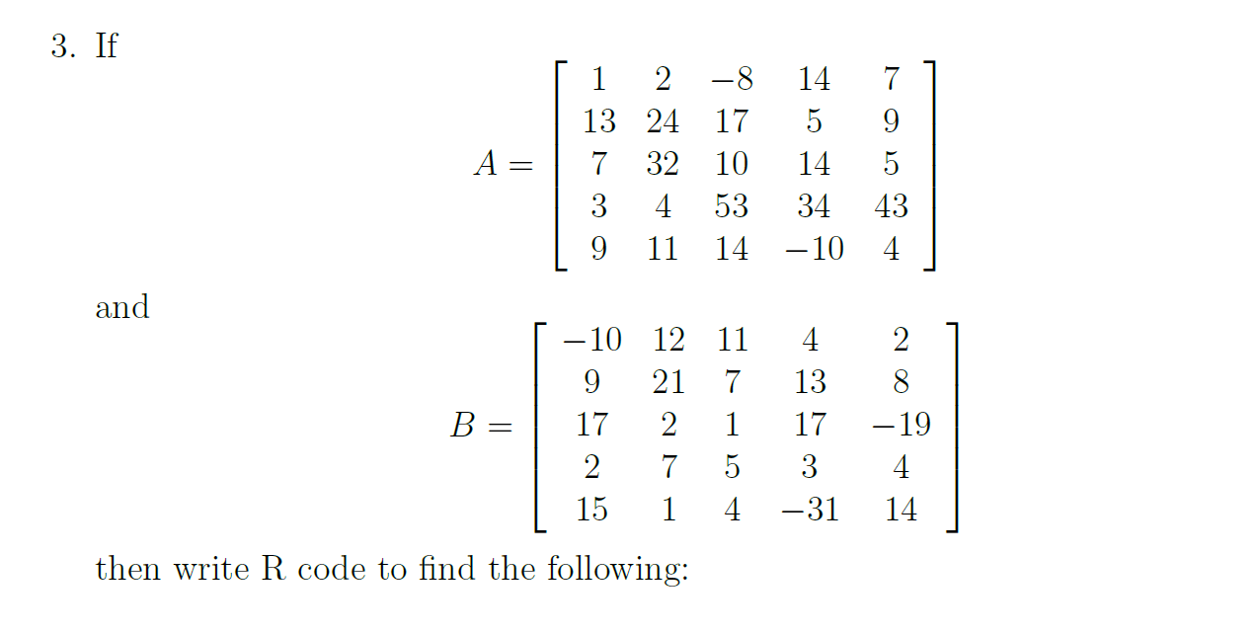  
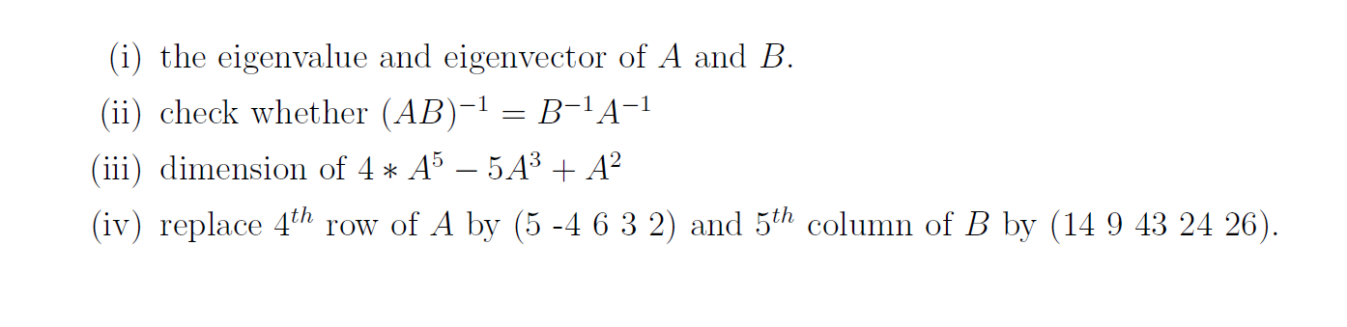

Matrix-A and Matrix-B

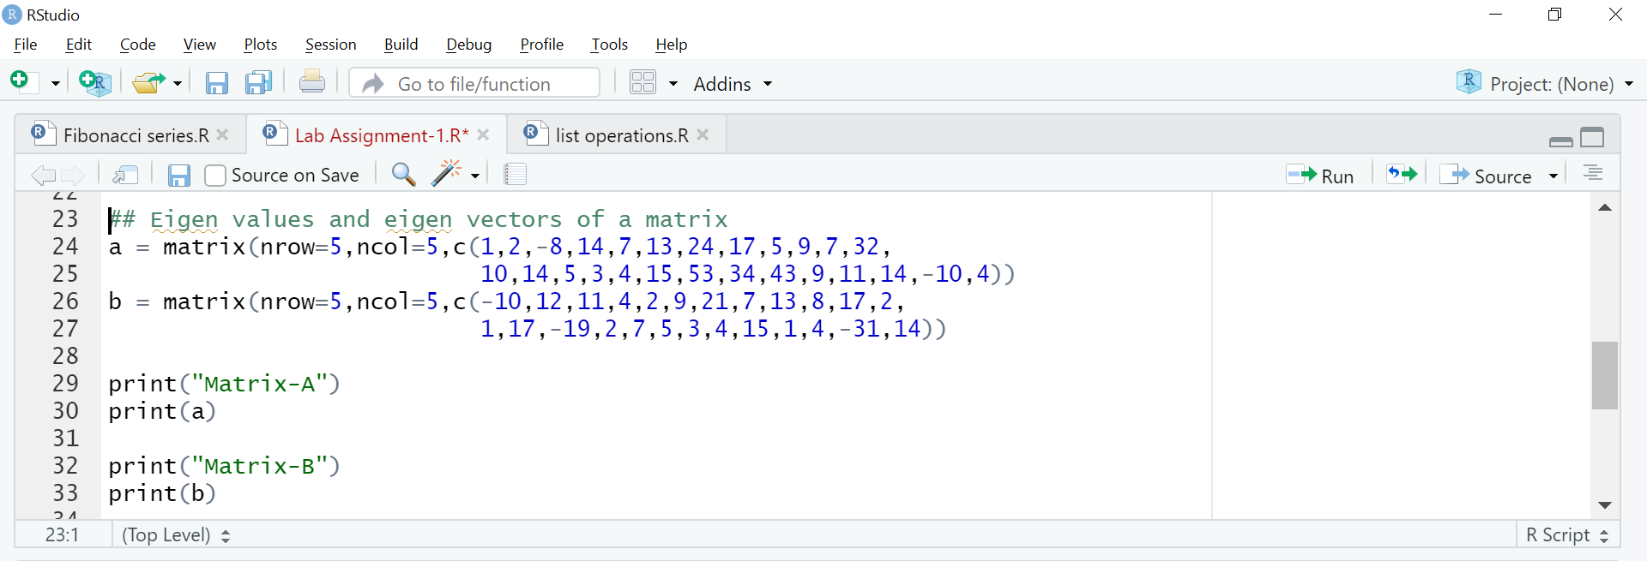

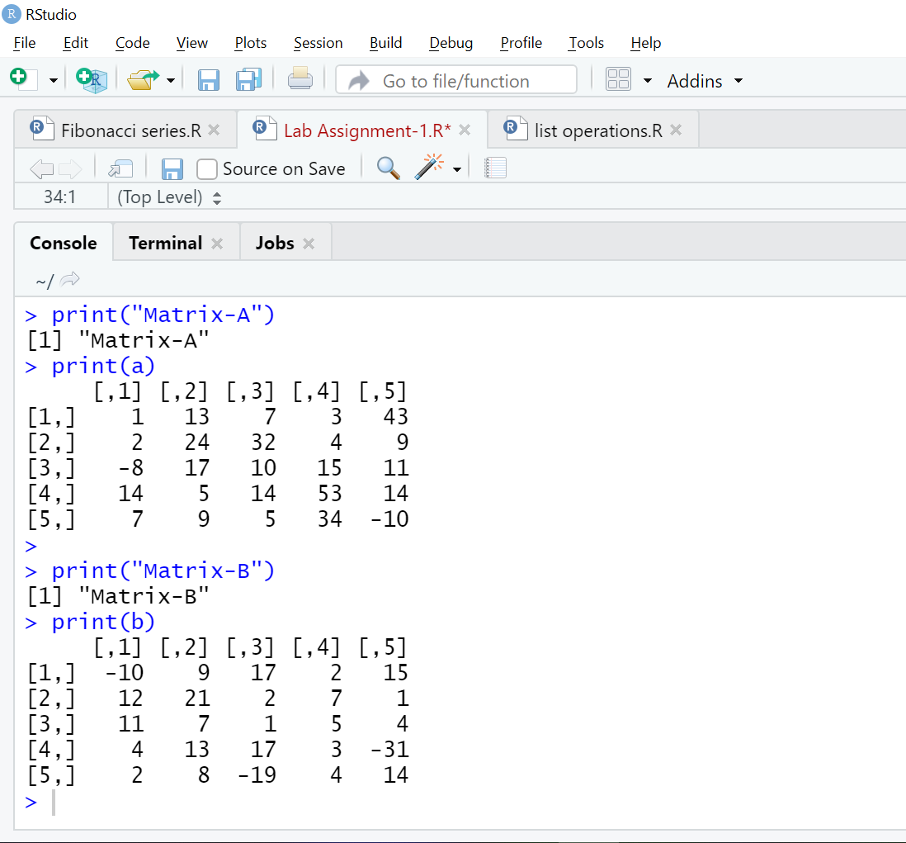

i)Eigen values and eigen vectors of A and B

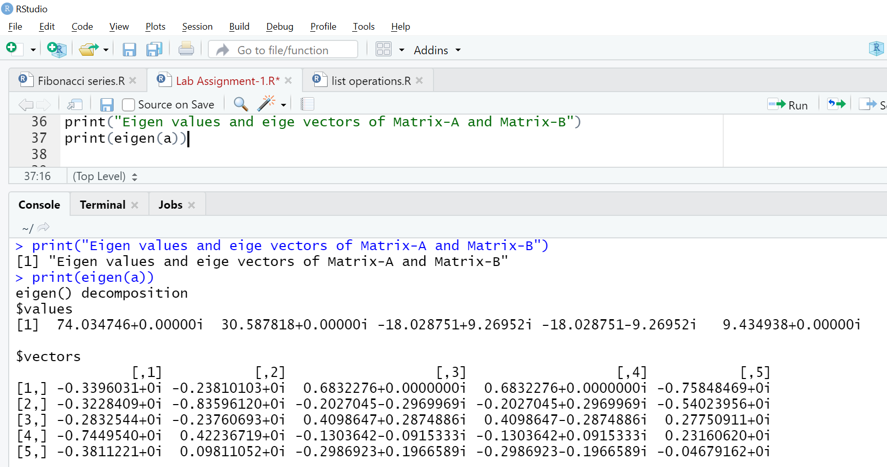

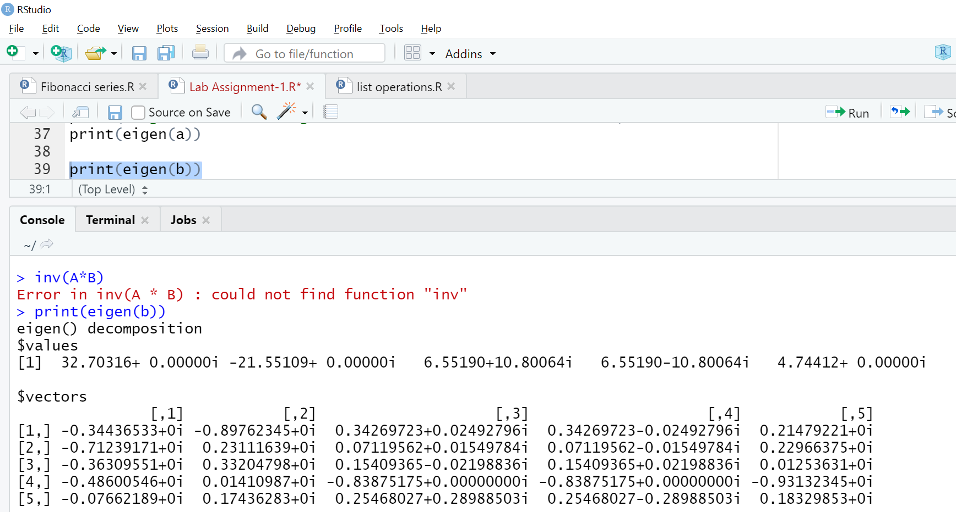

ii) Check whether (AB)^-1 = B^-1 * A^-1

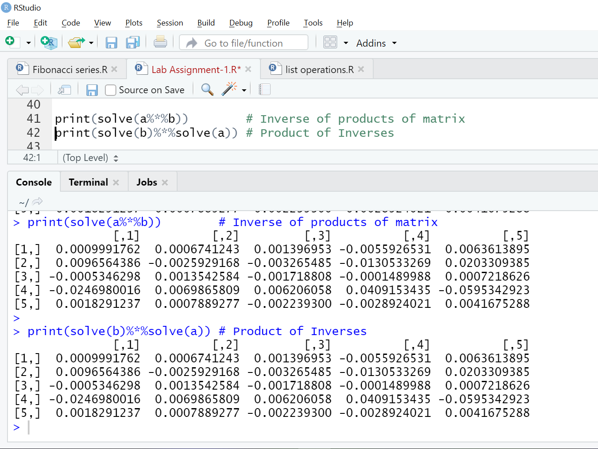

iii) Dimension of 4*A^5 - 5A^3 + A^2

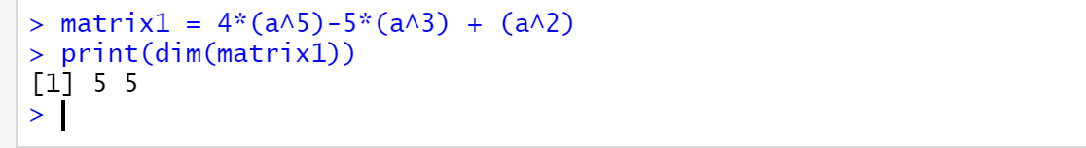

iv) Replacing 4th row of A by (5 -4 6 3 2) and 5th column of B by (14 9 43 24 26)

